Assignment 1

Requirement Engineering
___________________________________________________________________________________

Step 1: Business Identification
Company Name: MediFlow AI.
Business Nature: A HealthTech startup specializing in AI-assisted diagnostic tools for small-to-medium clinics.
Project Goal: Developing an automated "Smart Triage" system to analyze patient symptoms via a mobile app and prioritize urgent cases.

Step 2: SWOT Analysis
Based on the business goal of implementing an AI triage solution, here is the SWOT analysis:
Strengths | Weaknesses
Proprietary NLP (Natural Language Processing) models tailored for medical terminology. | High initial development costs for a startup.
Partnerships with local clinics provide immediate testing grounds. | Dependency on the accuracy of AI to avoid misdiagnosis.
Opportunities | Threats
Growing demand for remote healthcare and telehealth services. | Strict data privacy regulations (like HIPAA) regarding patient records.
Ability to scale the software to larger hospital chains in the future. | Competition from established tech giants entering the medical AI space.

Step 3: Identify a Key Requirement
Requirement: The system must accurately categorize patient submissions into three urgency levels (Emergency, Urgent, Routine) within 30 seconds of data entry.
Deliverable: A functional API and mobile interface module integrated with the clinic's existing database.
Time Bound: The pilot version must be developed and tested within 6 months.
Cost Bound: The project budget is capped at $150,000 for initial development and HIPAA-compliant cloud hosting.

Step 4: Prioritize Stakeholders (Power-Interest Grid)
Based on the "Smart Triage" project for MediFlow AI, we categorize stakeholders to determine how to manage them effectively.
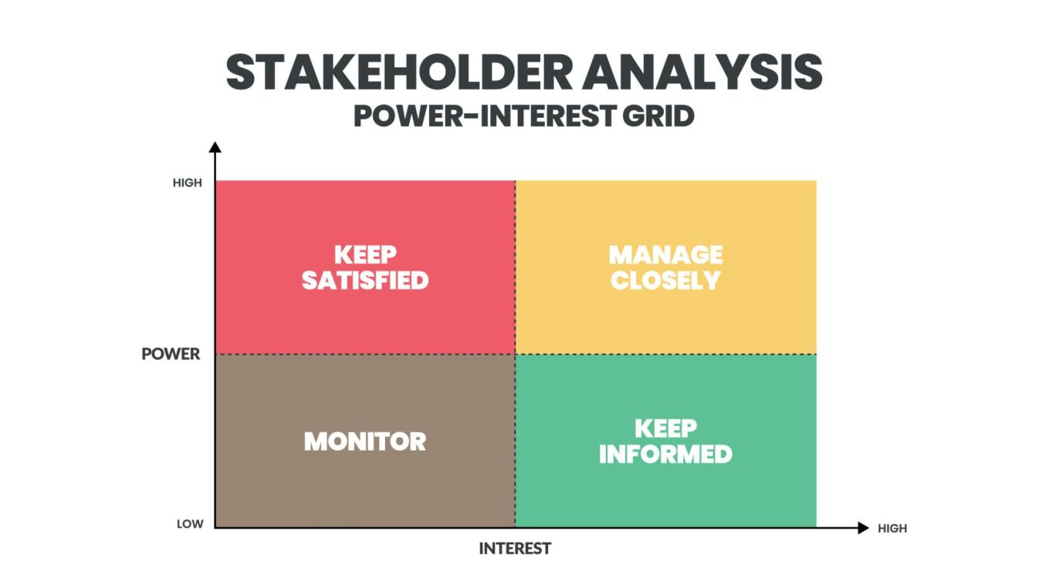

High Power, High Interest (Manage Closely):
- Clinic Owners/Management: They fund the project and their business operations depend on its success.
- Project Manager: Responsible for the actual delivery of the solution.

High Power, Low Interest (Keep Satisfied):
- Regulatory Bodies (Health Dept): They have the power to shut down the project if it violates privacy laws but aren't involved in daily tasks.
- IT Infrastructure Vendors: Provide the cloud hosting required for the AI to run.

Low Power, High Interest (Keep Informed):
- Nurses and Medical Staff: They will use the system daily; their workflow changes significantly.
- Patients: The end-users whose symptoms are being analyzed.

Low Power, Low Interest (Monitor):
- General Tech Community: May follow the startup’s progress but has no direct impact or stake in this specific project.

Step 5: Requirement Classification
Following the guidelines to identify different levels and types of requirements:

Part A: Hierarchy of Requirements
- Business Requirements: To reduce patient wait times by 40% and increase clinic efficiency by automating the initial sorting process.
- Stakeholder Requirements: Doctors and nurses require a dashboard that highlights "Emergency" cases at the top of their patient list immediately.
- System Requirements: The system must be able to process and store data in a HIPAA-compliant encrypted database with 99.9% uptime.

Part B: Functional, Non-Functional, and Domain Requirements
- Functional Requirements:
  - The system shall allow patients to register and create a secure profile.
  - The system shall accept symptom descriptions via natural language text input or voice.
  - The system shall generate an urgency rating (Emergency, Urgent, Routine) for every submission.
  - The system shall notify the duty nurse immediately if an "Emergency" rating is generated
- Non-Functional Requirements:
  - The AI response time for categorizing symptoms must be under 30 seconds to ensure performance.
  - The AI must process and categorize symptoms within 30 seconds of submission.
  - The system shall maintain 99.9% uptime to ensure 24/7 access for patients.
  - The system must accurately identify 95% of high-risk "Emergency" keywords correctly.
- Domain Requirements:
  - The system must map all identified symptoms to the ICD-10 (International Classification of Diseases) or SNOMED CT terminology to ensure data compatibility with global electronic health records.
  - All data handling, storage, and transmission procedures must strictly adhere to HIPAA (Health Insurance Portability and Accountability Act) regulations for protecting sensitive patient information.
  - In accordance with medical safety standards, any symptom categorized as "Life-Threatening" must trigger an automated instruction for the user to "Call 911" or local emergency services immediately.
  - The AI’s triage logic and decision-making trees must be reviewed and digitally signed off by a board-certified medical professional before deployment.
  - The system must archive patient triage history for a minimum of seven years to comply with medical record-keeping legal requirements.

Step 6: RE Technique Selection
For the MediFlow AI Smart Triage project, the chosen technique is Semi-Structured Interviews. The semi-structured interviews are those type of interviews in which interviewee use both pre-prepared questions as well as make questions on the spot.

Selection Factors:
This project involves high-stakes medical domain knowledge and diverse stakeholders (Doctors vs. Patients). Interviews allow for exploring complex requirements that might not be captured in a static survey.

Context of Application:
Who: I will interview Senior Triage Nurses and General Practitioners.
Why: To understand the specific "red flag" symptoms that must trigger an immediate "Emergency" classification and to identify nuances in how patients describe pain.
How: Using semi-structured questions. This provides a framework to ensure all medical safety topics are covered while allowing doctors to explain edge cases or "gut feelings" they use in manual triage that the AI needs to mimic.

Step 7: Requirements Documentation
For a software system focusing on user interaction and system behavior, the Software Requirements Specification (SRS) is the most appropriate choice.
According to the standards for an SRS, the documentation for the "Smart Triage" system includes:
- Product Overview: A mobile-based AI diagnostic interface for clinics to automate patient sorting.
- Summary of Current System: Currently, clinics use manual paper-based intake forms or verbal descriptions, leading to delays in identifying critical cases.
- Proposed Methods and Procedures: The AI will use Natural Language Processing to parse user input and map it against a medical urgency database.
- Design Considerations: The interface must be high-contrast and easy to use for patients who may be in physical distress.
- Security Considerations: The system must implement end-to-end encryption and multi-factor authentication to remain HIPAA-compliant.

Sample Use Case (As part of SRS)
Field | Description
Use Case Name | Submit Symptom Report
Actor | Patient (End-user)
Description | Describes the interaction where a patient inputs symptoms and receives a priority level.
Step 1 | Patient opens the MediFlow app and selects "New Assessment."
Step 2 | Patient enters symptoms via text or voice.
Step 3 | System processes data and assigns a Triage Category (Emergency/Urgent/Routine).
Step 4 | System notifies the clinic dashboard of the new entry.

Submitted By :
Arshah Lamees L226979
Talal Jamil L22-6684

